Dear Community Member:
Thank you for agreeing to participate in our arsenic and uranium well testing program. We are conducting a study and our goal is to further understand and examine the occurrence of naturally-occurring arsenic and uranium in private wells in the state of Connecticut. This effort is partially being funded by the Centers for Disease Control (CDC).
When collecting a well water sample, please follow the directions below:
1. Turn on a commonly used faucet in the house, such as a kitchen sink, and let the cold tap water run for 5 minutes before collecting your sample. Running the water for at least 5 minutes will bring water into your household plumbing that is coming directly from the well.
2. If you do not have a treatment system installed at your house you can collect the sample directly from your kitchen sink (or commonly used faucet). If you have a treatment system, collect the sample at a location prior to treatment (see attached diagram*). Typically there is a threaded tap near the holding tank located in your basement.
3. Fill the 250ml bottle completely with a little bit of space below the neck of the bottle. At least half a bottle of water is needed to do an analysis. Tightly secure the cover to the bottle.
4. On the laboratory form (“Inorganic Chemistry Drinking Water Form”), record the following information:
- Date sample was collected, site name (i.e. kitchen sink, water tank), site address: address where the well is located, collector’s information: first and last name of sample collector, title (i.e. homeowner or tenant), phone number of person collecting sample, Additional Information: - mailing address where your results should be mailed.
- Time of sample collection
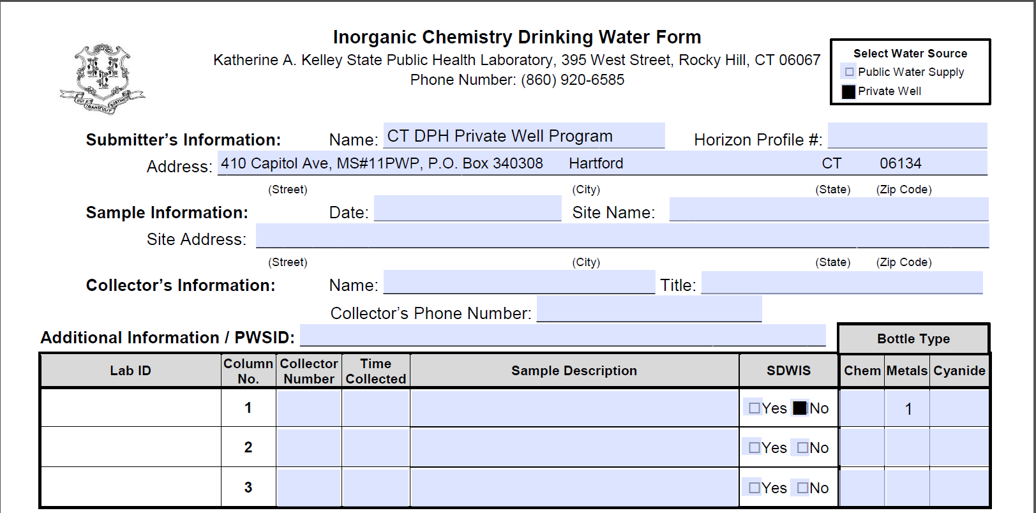
Mailing Address
Address where well is located

5. The sample does not need to be refrigerated. The sample and completed laboratory form needs to be dropped off at the designated location during the hours listed below before 4:00PM on Wednesday, November 15, 2017:
Hours: Thursday, 11/9/17 from 8:00 AM – 4:00 PM
Friday, 11/10/17 from 8:00 AM – 1:00 PM
Monday 11/13/17 from 8:00 AM – 4:00 PM
Tuesday 11/14/17 from 8:00 AM – 4:00 PM
Wednesday, 11/15/17 from 8:00 AM – 6:00 PM

Location: Collection Box at the
Torrington Area Health District
350 Main Street
Torrington, CT 06790

Phone: (860)489-0436

The results will be mailed to you when the analysis is complete. If the levels are higher than a Maximum Contaminant Level, then we will most likely recommend that you install a treatment system that will remove the contaminants from your well water. Please be sure to include your phone number on the laboratory reporting form so somebody from the Department of Public Health’s Private Well Program can contact you to provide technical assistance on treatment options, if needed. Please contact the CT DPH, Private Well Program at (860) 509-7296 if you have any questions.
*Diagram – Where to collect the sample when a treatment system is installed:
